**ADNAN MENDERES UNIVERSITY**

Name – Surname : Betül Berna Soylu

Number : 171805019

Class : CSE313

Delivery Date : 29.11.2020

**2020-2021**

**DECLARATIVE PROGRAMMING**

Question-1)

a-) Construct a valid argument in English the validity of which can be captured in first-order predicate logic but not in propositional logic.(5points)

⚫In predicate logic, as individual terms are variable, predicates can also be fixed or variable. The best examples of predicate constants are terms such as "number", "fruit", "satellite".

All people is mortal.

b-) Translate the argument into propositional logic(L1).

∀xP(x) is converted into proposition. P(x) means it is mortal.

c-) Re-translate the translation in (b) into Prolog.

?- mortal(all people) 🡪It is the prologue that the statement all people is mortal.

d-) Translate the argument into first-order predicate logic(L3).

?- mortal(all people). Displayed as Fa, not shown as aF.

a 🡪 shows all the people.

F 🡪 shows to be mortal.

e-) Re-translate the translation in (d) into Prolog.

?- F(a). 🡪 It is denoted as F(a) and expressed as such.

f-) Show that the argument loses its validity when translated into propositional logic with the appropriate prolog query.

p : The sun is hot

q : The ocean is wet.

p ∧ q : The sun is hot and the ocean is wet.

?- p∧q(p, q).

g-) Show that the argument retains its validity when translated into first-order predicate logic with the appropriate prolog query.

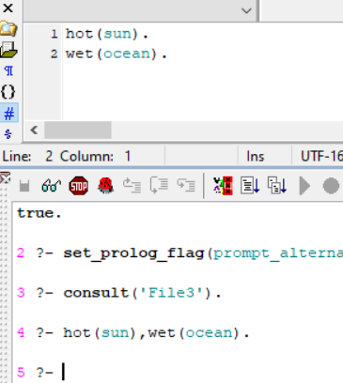

Question-2)

a-) Write a prolog program to determine whether or not a given list of characters is a palindrome.(15 points)

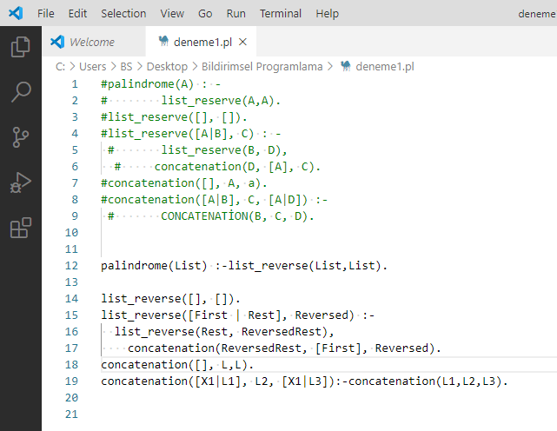

b-) Demonstrate with two queries that your program can distinguish between palindromes and non-palindromes.(5 points)

